Name:  Teacher : | ____________________________________  ______________________ |  | Date:_________
 | Year 7  SCORE:  /50  Mini Test 9  Topic – Statistics, Directive Numbers and Volume  Full working out MUST be shown to get full marks for each question.
Total Time: | 55 minutes
Weighting: | 8%
Equipment: | To be provided by the student: Pen, pencil, ruler, scientific calculator, 1 page of A4 notes

Section 1: No Calculator [37 marks]

- [2 marks]
Write the value of the numbers represented by the dot on each number line below.
a.

-15 -10 -5 0 5

b.

-9 -6 -3 0 3 6 9
- [4 marks]
Are the following greater or less than statements true or false?
- 4 > −5 true / false

- -7 < −5 true / false

- 11 > - 15 true / false

- -5 > -8 true / false

- [2 marks]
Arrange the following numbers in ascending order:(lowest to highest)
−5, −21, 14, −9, 26

- [4 marks]
Use the number lines to help answer the following questions.

- Find the value of −6+7.

-15 -10 -5 0 5 10
b) Find the value of 9−2.

-10 -5 0 5 10

- Find the value of −6+6+5.

-10 -5 0 5 10

- [8 marks]
Answer the following

- −6+17 =

- −13+13 =

- 6 – 11 =

- −14−14 =

- 7+ (−5) =

- −11− (−11) =

- −8+ (−5) + (−9) =

- [2 marks]
One evening in Moscow the temperature fell to −15°C. By midday the next day the temperature was forecast to be 3°C.

What was the expected rise in temperature from the evening to midday the next day?

- [3 marks]
Three contestants are heading into the final round of a game show. Hannah has 31 points and Maria has −8 points. If Skye has 17 more points than Hannah, how many points separate Maria and Skye?

- [3 marks]
All the students in your school take a survey with the four questions below.
Will the answers be catageroical or numerical data
- How many pets do you own? Categorical / Numerical
- How long did you spend on homework last night? Categorical / Numerical
- How many times have you broken your arm? Categorical / Numerical
- [3 marks]

- [3 marks]
Calculate the volume of the following if 1 cube is $1cm^{3}$

a)   | b)   | c)  

- [3 marks]
The cooking show Iron Hams has a panel of 30 judges. Each contestant is given a rating by each judge between 1 and 5. The dot plot below shows the results of the winning contestant from last year:

  - How many judges gave the contestant a rating of 4?

  - How many judges gave the contestant a rating of 4 or more?

  - How many judges gave the contestant a rating of 2 or less?

- [3 marks]
A city council selected a number of houses at random. They determined the fastest travel time from each house to the nearest hospital, and produced these results (in minutes):

34, 35, 18, 26, 24, 18, 17, 46, 34, 14, 45, 12, 28, 14, 29

Represent this data in an ordered stem-and-leaf plot, with commas between each leaf:
Stem | Leaf
1
2
3
4

Key: 2 ∣ 5 = 25

End of Section 1

Section 2: Calculator Allowed [13 marks]
- [6 marks]

5, 16, 8, 14, 15, 11, 12, 13, 8

The data above is the number of hours of television 9 friends watched last week. Use data to find;
- The mean

- The median

- the mode

- The range

- A different group of friends also recorded the number of hours of television that they watched last week. Their results showed the following.
Mean | 12
Median | 11
Mode | 10
Range | 5

With reasons, explain which group of friends watch more television last week.

- [7 marks]
Find the volume of the following
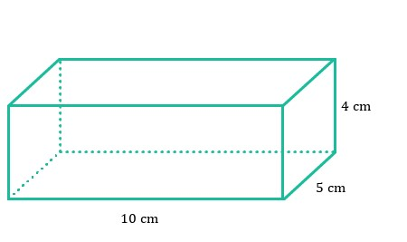
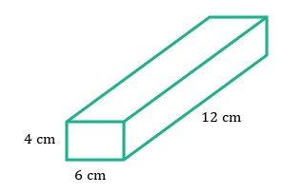
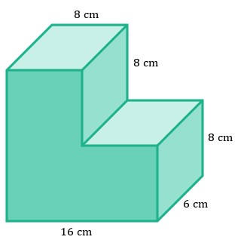

~End of Test~

